LAB # 07
Working with HTML and tables in HTML

Introduction
The acronym HTML stands for Hyper Text Markup Language. Hyper refers to the ability to link to various elements and go to them when the user decides to resource them. Markup refers to the things we do to make things appear different; bolding text for instance. HTML codes instruct web browsers such as Internet Explorer, Firefox, Opera and Safari how to display or present content without displaying the code. Content may include elements such as text, images, audio, video and other multimedia files.

Document Structure
Every HTML document has the following basic structure. It starts and stops with the
Code to tell the web browser accessing it that it is indeed an HTML page. Specific details can be embedded in the head section which are made use of by search engines, but are hidden to the viewer. Information for display is included in the body section.
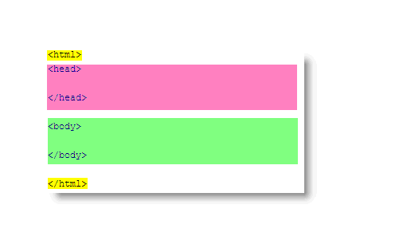
Coding Syntax
HTML formats all the information presented in your web browser with tags. Tags are always enclosed in the angled brackets < >. In order for them to work, they must be "spelled" correctly. Examples:
Tags tell the browser when to start formatting information with specific effects and when to stop them. The effects are stopped by using the same tag with a forward slash before the tag. Examples: This is the text we want to make bold.

Headings
Headings are used in html for the exact same reason they are used in print text. HTML has 6 levels of Headings built into the code. These are used to create a consistent look for all headings.
<h1> </h1>
<h2> </h2>
<h3> </h3>
<h4> </h4>
<h5> </h5>
<h6> </h6>
Lists
In HTML, there is very little you can do without tables to precisely place any information on the page. HTML lists aid the programmer in defining steps or items on their own. There are three types of lists available:
- Unordered Lists
<!DOCTYPE html>
<html>
<body>

<h2>An unordered HTML list</h2>

<ul>
<li>Coffee</li>
<li>Tea</li>
<li>Milk</li>
</ul>

</body>
</html>

- ordered Lists
<!DOCTYPE html>
<html>
<body>

<h2>An unordered HTML list</h2>

<ol>
<li>Coffee</li>
<li>Tea</li>
<li>Milk</li>
</ol>

</body>
</html>

Inserting Images
The terminology "inserting" an image is somewhat problematic. You are telling the webpage to display an image saved in your website at a specific location on the page. It should be thought of as "displaying" an image instead. Use the "img src" tag.

Example
<img src=”abc.png” />

<a>Tag
The <a> tag defines a hyperlink, which is used to link from one page to another.
<a href="url">Text</a>
The Table Element
Tables can be used for more than just displaying a table of data. Tables can also be used as formatting tool. The data in a table can be text or images.
The <TABLE> element lets the browser know that a table follows. The attributes to the <table> element apply to the table itself not the data displayed in the table.
Attributes
Align—This attribute specifies the alignment of the table.
Width—This attribute specifies the width of the table, not columns.
Border—The border attribute specifies that the border of the table should be drawn.
Cellspacing—This attribute specifies the spacing between cells
Cellpadding—This attribute specifies padding within cells.
Cell Spacing
Example:
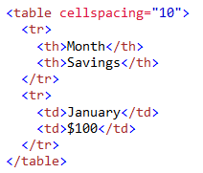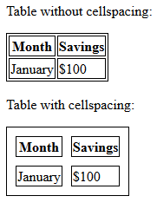

CELL PADDING
Example:
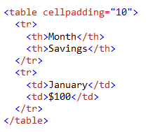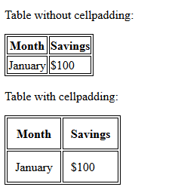
Table Elements
The <TR> (TABLE ROW) Element
The <TR> is for defining table rows. Inside the <TR> element is found the table header and table data element.
The <TH> (TABLE HEADER) and <TD> (TABLE DATA)
The <TH> and <TD> are the table cell element. They identify the data to be displayed in the table. Each occurrence of <TH> or <TD> within a table row (<TR>) defines a new column
Attribute
Align—this attribute is used to define the left\right alignment for data displayed in the column.
Width—this attribute is used to specify the width of the cell.
Height—this attribute is used to specify the height of the cell.
Colspan—this attribute is used to specify how many columns the cell is to span. The default value is 1.
Rowspan—this attribute is used to specify how many rows the cell is to span. The default is 1.
Example # 1
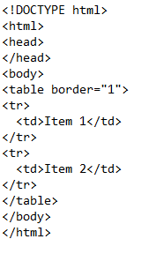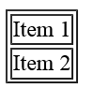
ROWSPAN
Example # 2
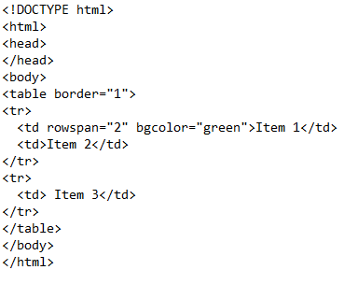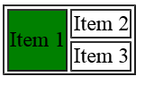

Example # 3
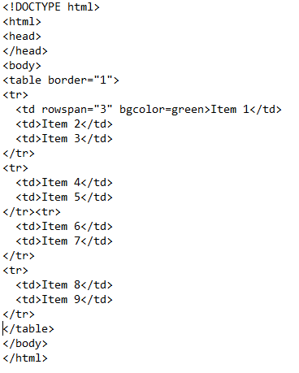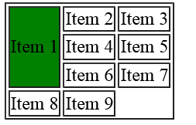

COLSPAN
Example:
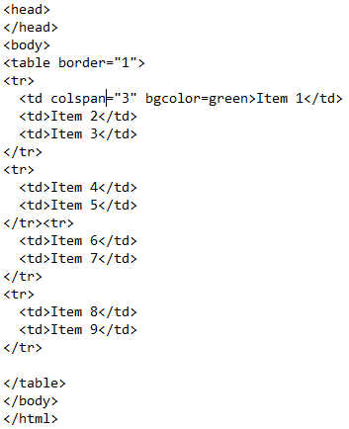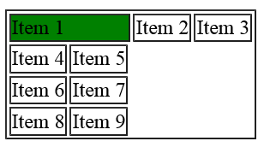

Lab Tasks
Task # 01: Design the following web page using heading H1 to H6.
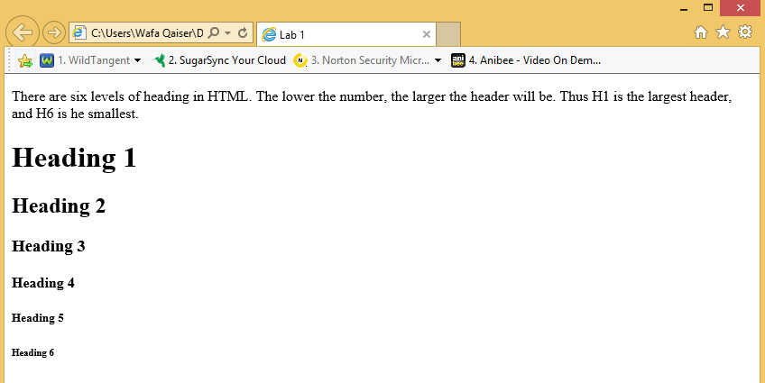
Task # 02: Using Center tag, design the following web page.
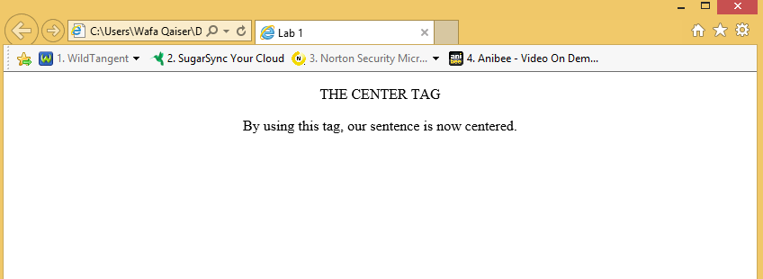
Task # 03: Create a hyperlink and navigate to it from your web page.
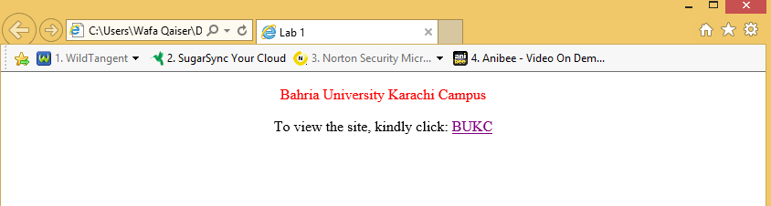

Task # 04: Using RowSpan along with Table tag, design the following tables:
- a) 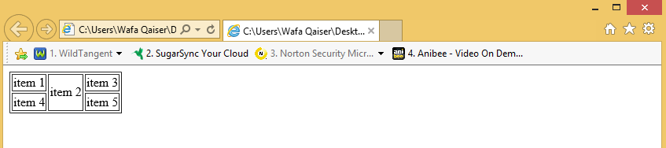

- b)
- 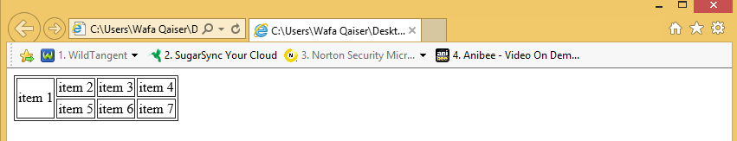
Task # 05: Using ColSpan along with Table tag, design the following tables:

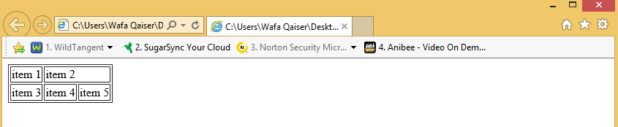

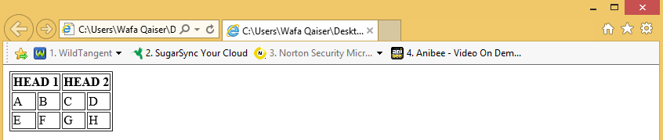

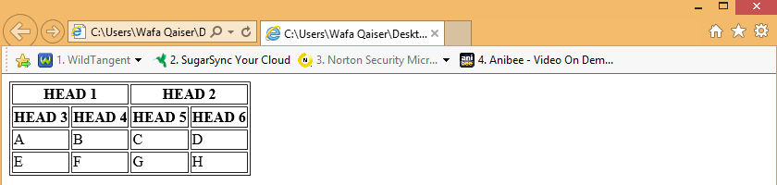
Task # 06: Using BGCOLOR attribute, along with ROWSPAN and COLSPAN design the following table:
